User Manual

How to Secure a File with a Password


Secure a file with password
There are two options for protecting a file with a password:
- Entering a password before the user can download the file.
- Entering a password when the user wants to open the file on their personal computer, after it has been downloaded.
It is possible to choose one of these methods or both, depending on the type of policy that has been defined. In both cases, the password will be the same and will be set by the sender separately for each recipient.
Password protection before the user can open/download the file (Option 1) can be applied in addition to authentication via a one-time password (OTP) sent to the recipient’s email or mobile phone, or instead of authentication in this way.
A protection policy can be defined that includes protection in all three ways: protection via a predefined password, authentication via a one-time code sent to the mobile phone, and authentication via a one-time code sent to email. Alternatively, a protection policy can be defined that protects the file using one or two of these methods.

Setting a policy that includes password protection
To share a file that is protected with a password, you must first define a policy that includes this type of protection.
Please note: Password protection applies at the file level, meaning that in order to open the file itself, the password must be entered. Since the protection applies only at the file-opening stage, the user must also complete authentication using a one-time password (OTP), which will be sent to their email or mobile phone, before they are granted access to open or download the files.

Stage 1- Setting a policy that includes password protection
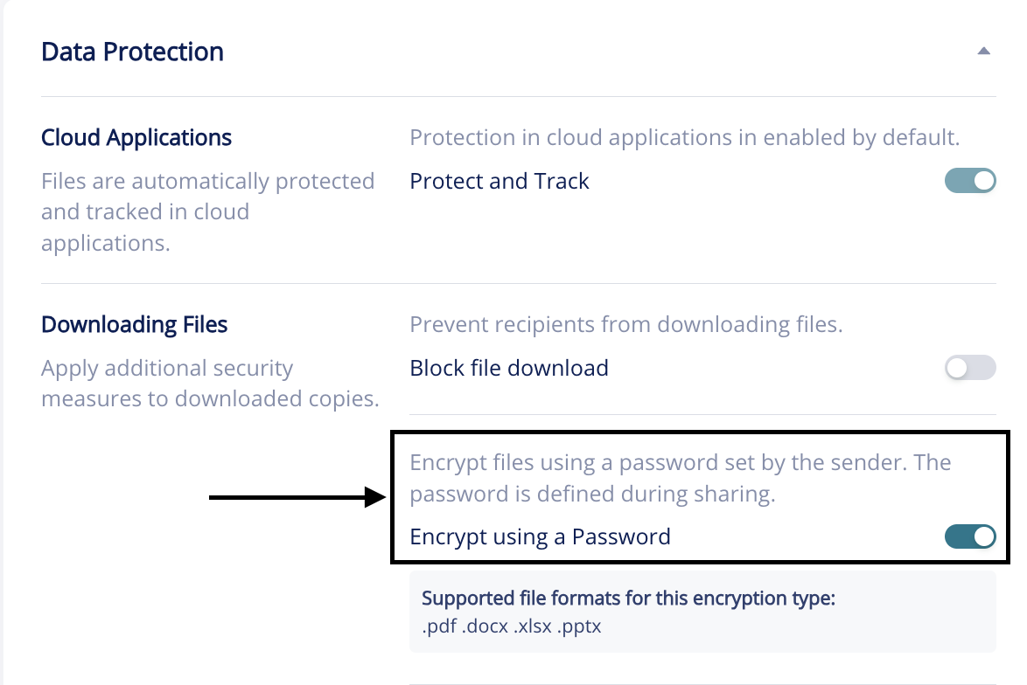

Step 2 – Sending a password-protected file via Outlook
After defining a policy, the user has to send the file in a protected manner and select the policy that includes password protection.
Once the policy is selected, the sender will enter the password that the recipient will use to open the file. This is done by clicking the pencil icon (marked in red in the screenshot).

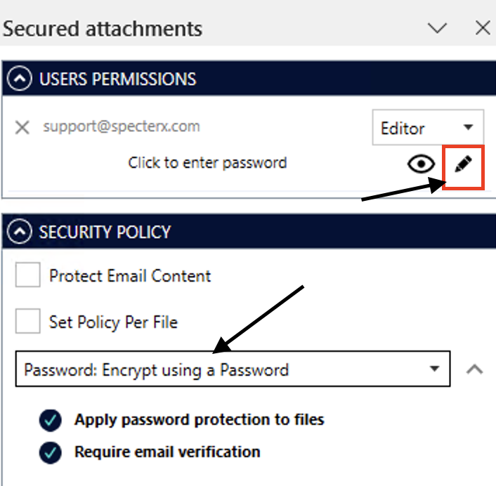

After clicking the pencil icon, a field will appear where you can enter the password. Type the desired password and confirm it by selecting the green checkmark.
Once the password has been entered for the first time, it will be saved for future use. You can change it at any time using the same method (clicking the pencil icon).
To ensure a smooth and user-friendly experience for the recipient, it is recommended to include a note in the email body that indicates which password they will need to enter. For example:
“The attached files contain sensitive information and have been sent to you securely. To view them, you must first authenticate using a one-time code that will be sent to you. After that, to open the files, please enter your ID number.”
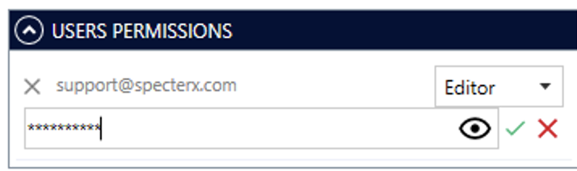

Step 3 – Opening the file by the recipient
When the email reaches the recipient’s inbox, the user should click the link and complete the authentication process using a one-time password (OTP). The OTP will be sent to their email or mobile phone, based on the protection policy that was selected.
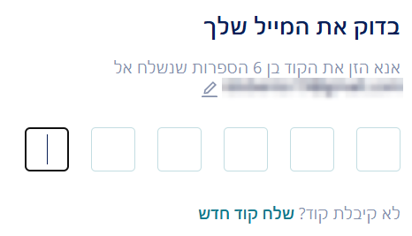

After the user completes the authentication process, the user will be able to download the files. To view the files after downloading them, the user must enter the password set by the sender.
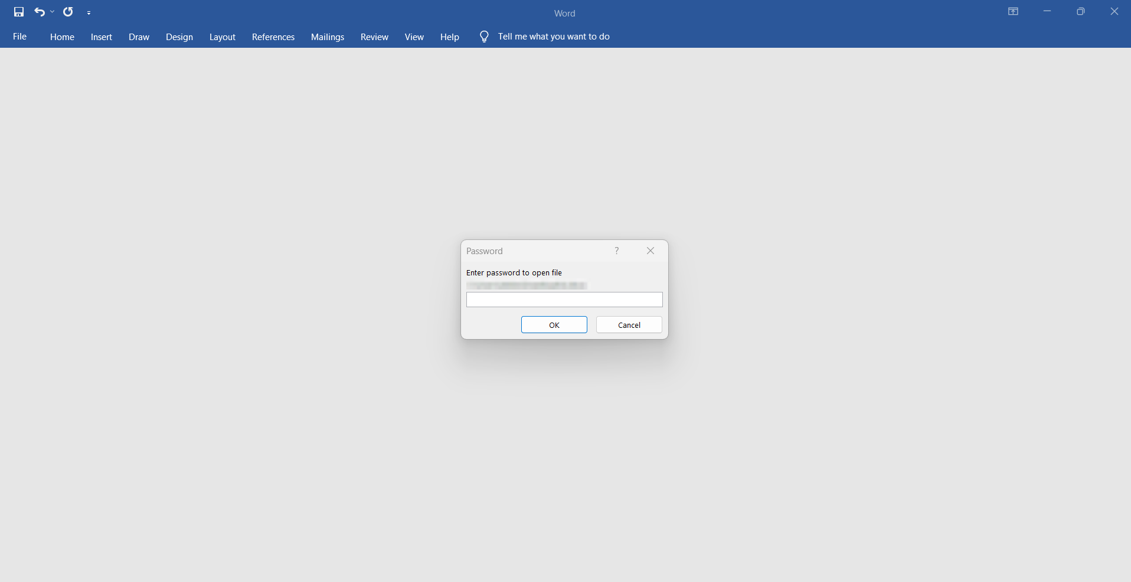
After entering the password, the user will be able to view the file!

If at any point you need assistance, our team is always glad to help.
Find us at: support@specterx.com

